A study on high efficient and energy saving lighting system for Jiuzi ancient town in CHina
Steve Lau Teng Hai, Haisheng, Xu
Hangzhou YD Illumination Co. Ltd.
Institute Of Intelligent Lighting
Stevelau@china-yd.com
ABSTRACT

According to the statistic published by Chinese National Tourism Bureau, during the holiday from 1st October to 7th October 2017, the number of tourists who travelled in the mainland China reaches 663 millions, and it has 11.96% jump if compared to last year, and the total income reaches RMB 549 billions! Statistic also showed that there is a tremendous increase of the the number of the tourists who paid a visit to Ancient Town. There is a trend that the people who stay and work in city areas (such as metropolitan cities like Beijing, SHanghai, SHenzhen and Guangzhou) who are willing to spend their holidays and stay overnight (or even several nights) with their family members in the ancient town. The ancient town not only able to attract tourist from local but also foreign visitors. This paper focuses on the theme of high efficiency and energy savings and summarizes the creative realization work (by proper tailor of light rays and also careful color selection) of the beautification and night landscape lighting of the Hui-style Ancient town in China- Jiuzi Ancient Town using high power LEDs. The night landscape lighting in Jiuzi Ancient town not only serves aesthetic value, economical value and environmental value on tourism, but also creates a primitive and quiet atmosphere at night and a perfect harmonization with the historical architecture.The key issues of this study work are the appropriate luminance distribution,luminance contrast, the smart use of color to meet the aesthetics need of old ancient town, integrated application of LED lighting science and technology, creating comfortable and peace illuminated environment of old architectures, applying green lighting and controlling light pollution.

Keywords: night landscape lighting, high power LEDs, high efficiency, energy savings, luminance distribution, luminance contrast, green lighting, light pollution

- INTRODUCTION

Light can bring two effects, if it is used wisely, it allows us to see and interacts with the world nicely,but if it is misuse, it can bring physical and psychological effects like light pollution, light damage to natures and in this case, if the light are not designed and used wisely, it could probably bring a total disruption of the natural and historical beauty of the ancient town. Hence the key element for the realization of the decoration work for the Jiuzi Ancient Town lies on the proper tailor of the light source and smart color selection in order to achieve a harmonization between the LEDs light and the landscape architecture. Before the restoration work using high power LEDs are done, Neon lights and incandescent light bulbs are being used for the illumination and decorative purposes and they are not as efficient as LEDs and also the lifespan of LEDs are also much longer if compared to Neon and incandescent lamp.Jiuzi ancient town is located in the Wuhu, Anhui province and it is the first merchant area cultural tourism in China. In the town, Ma Tau wall, Scale tile, Upswept Eaves, Pavilions can be seen everywhere, which is the typical presentation of Hui- style. The architecture roof, Ma Tau wall, Crenels, wooden Sculpture are decorated using LED wall washer and thus restoring and enhancing the lighting of the ancient architecture. It creates a harmonization between lighting and old architecture and a vivid picture of unique sights and watercolor painting.

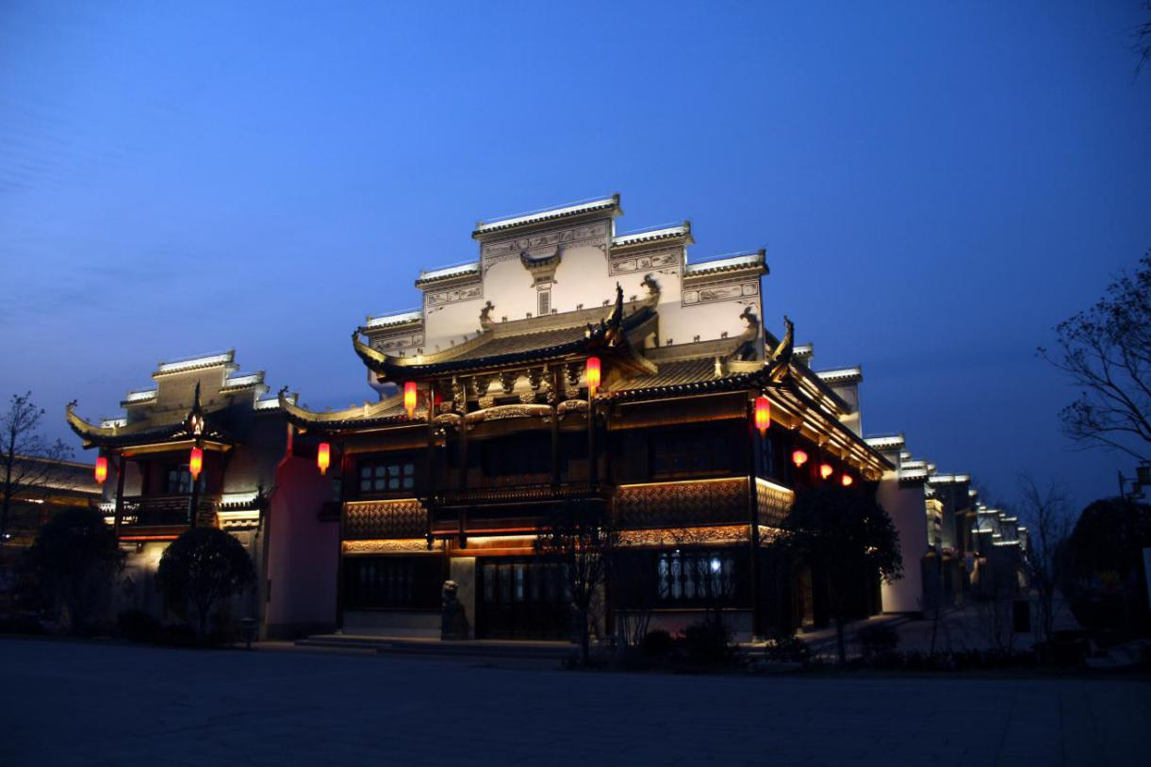
Figure 1: The Jiuzi Ancient Town illuminated with high power wall washer and linear LEDs. On top of the building, linear LEDs and wall washer with the color temperature of 4000K was used. For the lower part, the warm white LEDs with the CCT of 2700K linear and wall washer were used. This is to create two different layering for color perception.

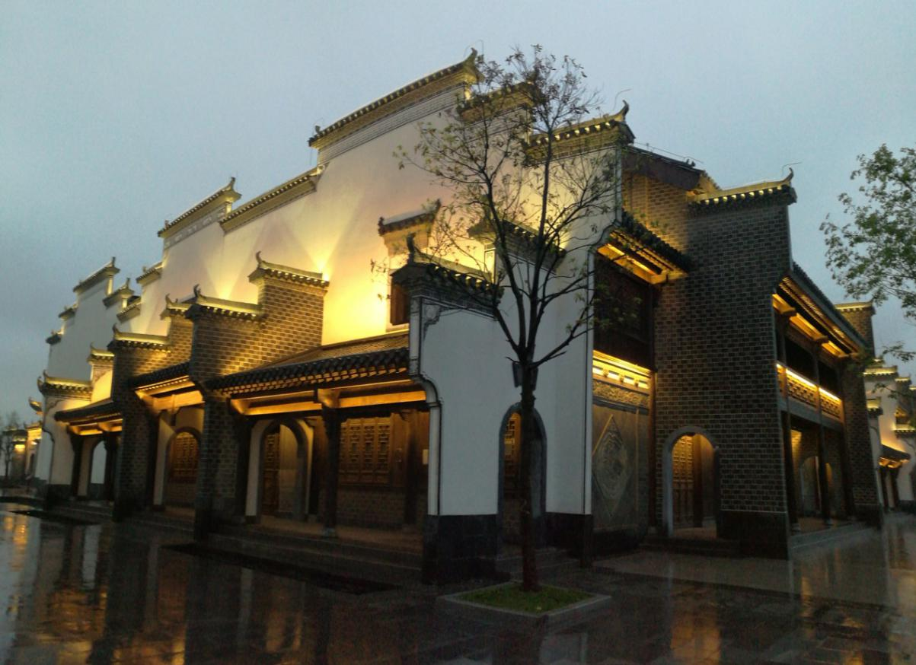
Figure 2: The LED wall washer and projection LEDs with the CCT of 2700K was used. Because the wall height varies, the LEDs was coupled with different optical lense in order to achieve the required projection height.

- Optical requirements for lighting systems:

2.1 Illumination requirements
Illumination is the basis of determining the brightness of the space.Compared to the modern outdoor facade lighting or outdoor lighting in modern shopping center, which the RBGW (Red, Blue, Green and White color) could be used in order to achieve color mixing and lighting control or even animations and graphic picture but this is strictly not applicable for the old ancient town. The Jiuzi old ancient town requires an illumination type that match perfectly with the architecture style, culture, historical background of the architecture. Furthermore, the light illumination possesses strong emotional factor. The illumination shall take care of the architecture style, functions, history and cultural background and features of the buildings. For the illumination design, it is crucial to create a sufficient luminance contrast and also to ensure harmonized luminance distribution.
2.2 The choice of color temperature
There are altogether 2 types of color temperature of the LEDs was used.The warm white LED (with the CCT of 2700K) was specially selected and chosen in order to create a hotness, warm, sunshine and magnificence whereas the neutral white LEDs (with CCT of 4000K) symbolizes peace, cold, and elegance feeling and sense. The warm color was chosen because it matches perfectly with the wooden dark brown color. Hence, the wooden sculpture are projected with the warm white (2700K). For the architecture roof, two color CCT was chosen, the highest roof was projected with neutral white, and the lower roof was projected with warm white color, the purpose is to create a clear contrast and two distinctive color layering between this two. Neutral white LEDs (with the CCT of 4000K) was also selected for the projection on the Ma Tau wall, because it helps to retain the neutral white surface of the Ma Tau Wall without altering much its original color perception.

2.3 The beam angle requirements
Because the height of the wall is varying from one to the other, hence, the optical lense has to be designed and characterized very carefully before they are being used. The optical lense changes the direction and light distribution of the LED and channel it to the required space. For the wall washer and linear LED light source used in this project, the wide angle optical lense (45°) are used solely, this is to achieve the uniform and comfortable luminance distribution when the observer sees the light from the ground. However, for the projection purpose, two different type of the optical lense was purposely designed and used (15° and 45°) , the 15° optical lense changes the light ray and concentrate them to the center of optical axis, hence it can achieve higher projection height.
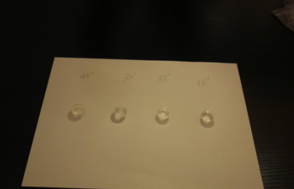
Figure 3a: shows the different type of optical lense to achieve the beam angle requirement, From the left to right: 15°, 25°, 30°, 45° optical lense
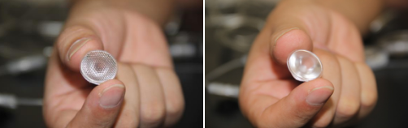

Figure 3b: the optical lenses (15° and 45°) were specially designed to achieve the beam angle control for the wall washer and LED projection application. Before they are put in the application, they are carefully characterized using Goniophotometer Everfine GO-2000.
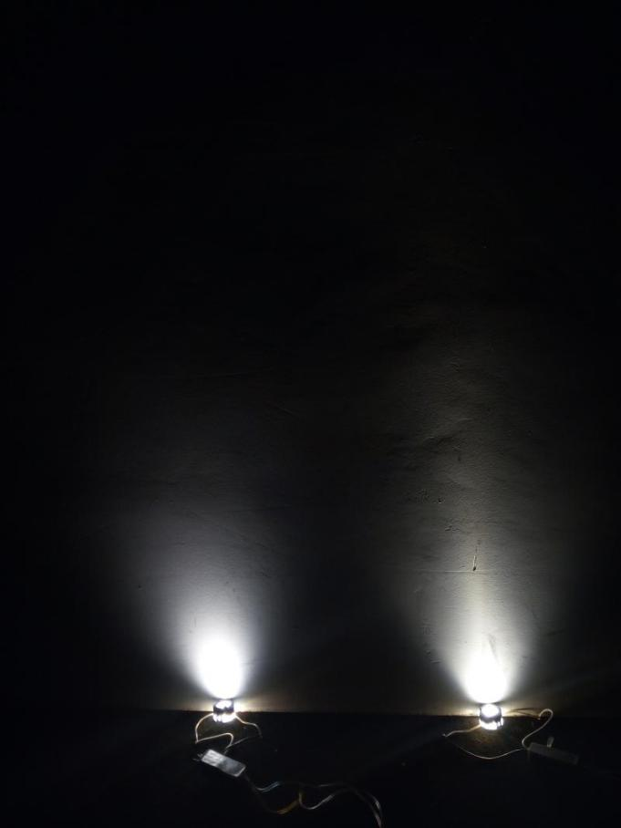
Figure 3c: two similar LED was compared side by side in the lab, the left one use 45°, and the right one use 15°, it is clear to see that for 15° the projection height of LED light is higher than 45°.
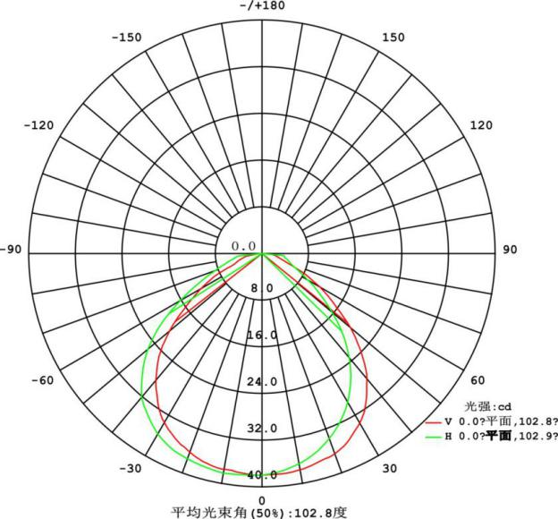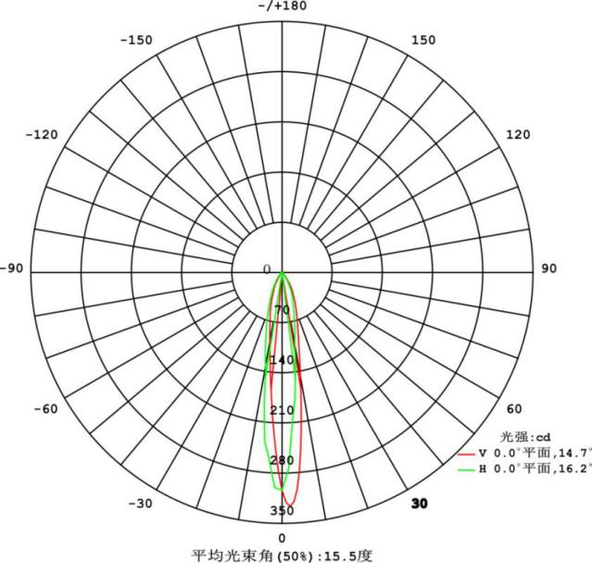

Figure3d: the comparison of the radiation profile for the LED module solely (left) and LED module with an 15 degree optical lense (right). The measurement was done using Everfine GO-2000 in the Test Lab.

- Innovative design method using LED integrated devices

3.1 See the light but do not see the lamps
The LED luminaires used in this lighting project has to meet many other requirements. The LED luminaires has to be pasted and integrated into the architecture perfectly so that it can achieve the effect of “see the light but do not see the lamps.It has the lamp and wire slot perfect integration and the lamp body is compact and small size in order for the luminaires to be hidden and does not affect the daytime effect of the building. Hence the LED luminaires are designed to have a ultra narrow and thin size for the linear lights source so that they can be fit inside the limited space of the buildings. Because the lamps are fully embodied inside the architecture, it solves the glare issue and light pollution caused by the light rays as the observers only see the reflection light from the wall or under the roof. The color appearance of the lighting fixtures are also painted so that it matches the color appearance of the wooden walls and roofs.
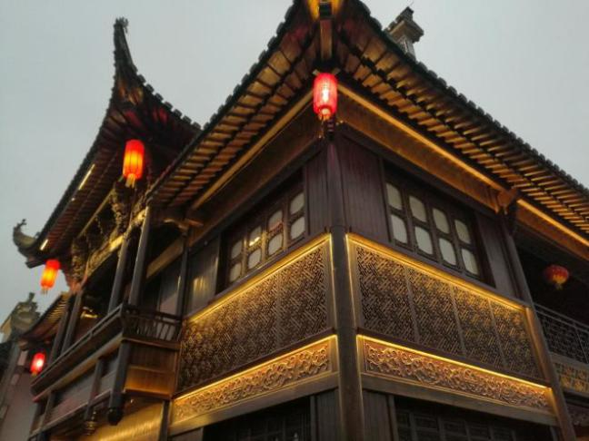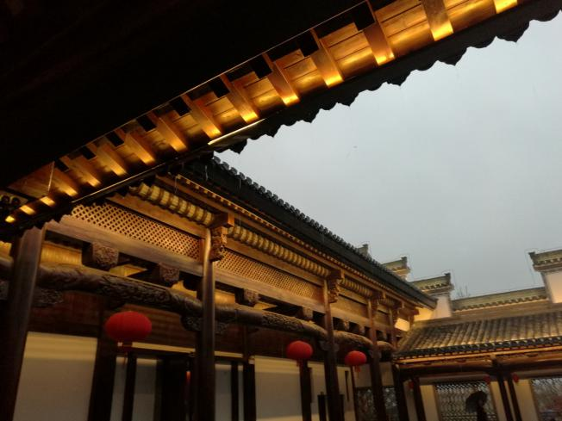
Figure4: This two picture show the perfect integration of the LED luminaires and the building in order to achieve “see the light but do not see the lamps”.

3.2 Safety, efficacy and reliability
Because the old ancient town are protected and it has historical meaning, the fire safety of the led luminaires used are indeed important, hence the LEDs module are properly designed and encapsulated to achieve the fireproof grade of V-0 and the IP protection grade of IP68, this is to ensure the fire safety requirements and also the protection against the rain fall, dust and extreme environment (- 10 degree C in winter up to 40 degree C in summer) from damaging the LEDs. Not only that, the material used in the encapsulation and to create a double protection layer of the LED must possess good transmittivity (more than 90%) so that the photon are not being trapped by the protection layer and yet it is sufficient to protect the LED from water leaking in. Furthermore, because of the heat generation from the high power LED, the material also consists of the heat dissipation nanotechnology material in order to ensure excellent heat dissipation. This is important not only to ensure consistent optical output because all the optical parameters (like Luminous flux, CCT, and wavelengths of LED) are highly dependent of the thermal management and thermal consistency but also is crucial to guarantee high reliability of LED life time. Furthermore, more heat is able to be dissipated to outside environment means the improvement of the lumen efficacy of the LEDs.

- Conclusion

This paper demonstrates successful realization of the beautification and night landscape lighting using high power LEDs, which beforetime, the Neon lights and incandescent lamp was used. Besides less energy consumption and longer life span for LEDs, this paper also demonstrates step by step how the strength and the unique characteristic of LEDs could be fully utilized to achieve illumination, CCT and also beam angle requirements in order to achieve the perfect matching of the lighting system with old ancient town of Juizi in Anhui. This paper also outlined several crucial importance of the LED luminaires requirement like small and compact size of luminaires, to have highest protection of IP 68 (for dust and water protection), fireproof grades of V-0, and the weather resistance, heat dissipation of the LED luminaires which play key role in ensuring the long life span of the LED used in the lighting system. The successful of the realization of LED beautification and night landscape lighting of Jiuzi ancient town could bring aesthetic value, economic value and historical and cultural value enhancing for tourism.

REFERENCE
- Xiao Huiqian, urban night lighting planning and design (M), Beijing, CHina Construction Industry Press 2003.
- Haiying Pen, Research on Urban Night Scene Design with Regional Cultural Characteristics, Xi’an University of Architecture and Technology 2007

ACKNOWLEDGEMENT
Corresponding Author:
Steve Lau
Institute of Intelligent Lighting
No. 650, Wangmei Road, Yuhang District, Hangzhou City, CHina
Tel: +86 182 5823 0263
Email: Stevelau@china-yd.com

